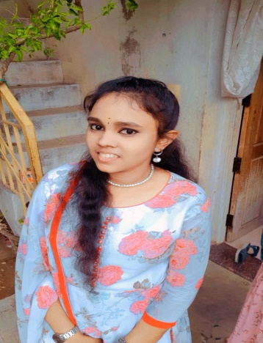



**MASTER DEGREE:**

**EDUCATION QUALIFICATION:**

My objective is to obtain a position in a professional office environment where my skills are valued and can benefit the organization. Ideally, I wish to have a focus in marketing for a growing organization preferably dealing in commercial real estate and/or land acquisitions.

**CAREER OBJECTIVE:**

**Shubanu Shree M**

* Tamil
* English
* HTML
* CSS
* JavaScript

**TECHNICAL SKILLS**

* Problem solving
* Leadership
* Communication

**SKILLS**

Address:

108 Paramasivan Kovil street, Bodinayakanur

Phone:

9384244885

Email ID:

shubanushreem@gmail.com

**LANGUAGES**

**CONTACT ME**

**DECLARATION:**

I hereby declare that the information furnished above is true to the best of my knowledge

SSLC

**ZKM Matric Hr Sec School 2018**

Percentage-84%

HSC

**ZKM Matric Hr Sec School 2020**

Percentage-69%

**SCHOOL:**

B.Sc,.Mathematics

**CPA College Bodinayakanur 2020-2023**

Percentage-85%

**BACHELOR DEGREE:**

MCA

**Madurai Kamaraj University 2023-2025**

Percentage-pursuing